WAH4PCE: An AI-Driven Interoperability Bridge for iHOMIS

Project Documentation Submitted to the Faculty of the
School of Computing and Information Technologies

Asia Pacific College

In Partial Fulfillment of the Requirements for
Systems Analysis and Detailed Design for IT and CS
MSYADD1/SSYADD1

By
Vince Nelmar Alobin
Rick Francis Cruz
Marwin John Gonzales
Qelvin Joszeler Nagales

Project Adviser
Gil Ballesca
Table of Contents
Executive Summary i
List of Figures ii
List of Tables iii
I. Introduction 1
1.1 Project Context 1
1.2 Statement of the Problem 1
1.3 Objectives 1
1.4 Significance of the Project 2
1.5 Scope and Limitations 2
II. Review of Related Literature / Systems 3
III. Technical Background 4
3.1 Current System 4
3.2 Proposed System 4
IV. Methodology 4
4.1 Requirements Analysis 4
4.1.1 Product Backlog / User Stories 4
4.1.2 Use Case Diagram 4
4.1.3 Use Case Full Description/Fully Dressed Use Case 4
4.2 Gap Analysis 4
4.3 System Analysis and Design 4
4.3.1 System Context Diagram 4
4.3.2 Container Diagram 4
4.3.3 Component Diagram 5
4.3.4 Entity Relationship Diagram 5
V. Results and Discussion 6
5.1 Release Plan 6
5.2 Prototype 6
5.3 Use Classes and Characteristics 6
VI. Conclusion 7
References 8
Appendices 9
Appendix A: Project Vision 9
Appendix B: Schedule 10
Appendix C: Product Roadmap 11
Appendix D: Users’ Manual 12
Appendix E: Team Meetings 13
Appendix F: Source Code 14

Executive Summary
The realization of the Universal Health Care (UHC) Act across the Philippines is critically hindered by isolated "data islands," where clinical records remain locked within fragmented health software systems. While Wireless Access for Health (WAH) facilitates modern HL7 FHIR-compliant exchanges among its partnered clinics, cross-facility communication completely breaks down when sharing records externally with Department of Health (DOH) facilities running the Integrated Hospital Operations and Management Information System (iHOMIS). This format mismatch forces healthcare personnel to rely on slow, error-prone manual re-encoding, increases the risk of data pollution, and exposes facilities to Data Privacy Act (RA 10173) violations during cross-network patient referrals.
To address this critical gap, WAH4PCE (Wireless Access for Health for Interoperability External) deploys the ADAPT (Automated Data Processing and Transformation) middleware engine as a localized API gateway. The system employs a robust Medallion Data Architecture to stage and process information securely through Bronze (raw health data), Silver (validated and cleansed data), and Gold (translated, interoperable data) layers.
- Algorithm-First Translation Engine: The core translation infrastructure relies on a deterministic, precise algorithm to handle the complex mapping between WAH (FHIR R4) and DOH iHOMIS (HL7 v2) schemas. Artificial Intelligence (Google Gemini via MCP) is strictly utilized as a fallback mechanism to process edge cases and unmapped fields. This structural shift guarantees processing efficiency, reduces API token costs, and ensures that unnecessary extra fees are not passed down to patients.

- Automated Privacy Gatekeeping & OpenAPI Standards: The middleware proactively isolates missing mandatory fields (such as PhilHealth numbers) to prevent data pollution. It features an automated privacy gatekeeper that instantly halts and quarantines unauthorized transfers lacking verified digital patient consent. Furthermore, WAH4PCE provides formal, standardized OpenAPI documentation for external API partners to consume seamlessly.
- High-Performance, Scalable Architecture: Built on a modern tech stack (Golang, MongoDB, Next.js), the system utilizes an intelligent mapping layer that processes in-memory payloads without permanently retaining confidential patient data.
By establishing this secure, algorithm-driven API prototype, WAH4PCE provides WAH and public healthcare stakeholders with a proven, scalable model to eliminate data silos and safeguard patient rights, without overextending into an unfeasible nationwide infrastructure development.

List of Figures
(
Add this to your paper if there you have inserted figures; otherwise, delete this section, including the header
To add a list of figures,
- Ensure that each figure has been properly captioned (Right click→Insert caption)
- Put the cursor below the List of Figures heading, then go to the References tab and click on Insert Tables of Figures located in the Captions group. The caption label should be set to Figure.
)

List of Tables
(
Add this to your paper if there you have inserted figures; otherwise, delete this section, including the header
To add a list of figures,
- Ensure that each figure has been properly captioned (Right click→Insert caption)
- Put the cursor below the List of Tables heading, then go to the References tab and click on Insert Tables of Figures located in the Captions group. The caption label should be set to Table.
)

Introduction
In many cases, healthcare suffers from the way patient information is stored and shared. As each hospital or clinic operates its own independent computer system, transferring patient records between healthcare facilities remains a significant challenge, resulting in isolated "data islands". Within the WAH network, partnered clinics and hospitals can easily share data because their systems use the HL7 Fast Healthcare Interoperability Resources (FHIR) R4 standard. However, a major barrier occurs when a WAH-partnered hospital needs to send patient data externally to a government hospital using iHOMIS, as the two systems utilize completely different data formats. This incompatibility results in slow care and a heavy reliance on manual, pen-and-paper processes.
While the Universal Health Care (UHC) Act mandates the implementation of interoperable information systems, the development of a national infrastructure is currently on hold, creating a critical need for local organizations to establish their own platforms. The previous WAH4PC development batch successfully established a baseline interoperability server, but its capabilities were strictly limited to internal communication within the WAH ecosystem. As the direct technical inheritor of this baseline, WAH4PCE upgrades the infrastructure by introducing the Automated Data Processing and Transformation (ADAPT) engine. Designed as a highly focused, localized Proof of Concept (PoC), WAH4PCE acts as a functional API bridge rather than attempting to construct a massive nationwide architecture.
To ensure data integrity, the system implements a Medallion Data Architecture. Incoming health records are ingested as raw payloads (Bronze layer), cleansed and validated for completeness (Silver layer), and structured into interoperable target formats (Gold layer). Crucially, the primary translation engine powering this transformation is a deterministic, precise mapping algorithm. Artificial Intelligence (Google Gemini via a Model Context Protocol server) is employed strictly as a fallback safety net for edge cases and complex, unmapped fields. This algorithm-first architecture prioritizes processing speed, drastically lowers API token costs, and prevents the accumulation of financial burdens that could inadvertently be passed down to patients.
Additionally, to adhere to the right to data portability under the Data Privacy Act of 2012 (RA 10173), the system operates as an automated legal gatekeeper. It scans incoming records to verify the presence of explicit legal consent, automatically blocking and quarantining the transfer if the consent is missing or invalid. The finalized API gateway will be exposed to external partners, such as DOH iHOMIS, complete with standardized OpenAPI documentation to ensure clear, formal, and strictly governed integration guidelines.

Statement of the Problem
The primary problem is the lack of an automated, working system that can securely translate and share patient records between local WAH clinics and outside government hospitals (iHOMIS).
Specifically, this study aims to answer the following problems:
- Missing Outside Connections: The current WAH4PC system is built only for internal use; it lacks the clear technical connection points and standard manuals needed to link easily with external Department of Health (DOH) systems.

- Poor Data Quality Control: The system lacks a step-by-step filtering process to catch incomplete patient records (such as those missing PhilHealth IDs) before they are shared, which risks spreading bad or missing data across hospital networks.

- Inefficient Translation: Translating patient data between the WAH format (FHIR R4) and the iHOMIS format (HL7 v2) currently relies on slow manual typing or expensive AI, rather than a fast, exact, and affordable rule-based computer program.

- Inability to Handle Unusual Data: A strictly rule-based program is rigid; it cannot always figure out unusual data, blank fields, or mismatched medical terms without a smart backup system to help translate those confusing cases.

- Privacy Risks: The current setup lacks an automated privacy checker, creating a serious legal risk of sending sensitive patient records to outside hospitals without first verifying the patient's digital consent.

Objectives
The primary objective of this project is to design and implement an algorithm-driven API bridge that securely translates patient records between the internal WAH ecosystem and external iHOMIS Implementing Hospitals.
Specifically, this project aims to:
- To connect the internal system to outside hospitals: Upgrade the current server into a secure gateway and provide simple, standardized instruction manuals (OpenAPI) so external government hospitals can easily connect to it.

- To ensure data quality using a step-by-step filter: Create a three-step data checking process (Medallion Architecture's Bronze, Silver, and Gold layers) that automatically cleans the records and blocks incomplete forms before they are sent.

- To automate translation using strict rules (Algorithm-First): Build a fast, exact computer algorithm that automatically changes health records from the WAH format into the iHOMIS format, drastically reducing costs and manual data entry.

- To use AI as a backup for unusual data: Add Google Gemini AI as a "Proof of Concept" safety net to read and translate confusing or unmapped data fields that the strict computer rules cannot understand.

- To automatically enforce data privacy laws: Build a digital legal gatekeeper that scans every medical record and immediately blocks the transfer if the patient's explicit consent flag is missing.

Significance of the Project
This project offers practical, immediate benefits by improving how health data is shared securely within a realistic timeframe. The specific groups that will benefit from this project are:
- For WAH and DOH: It provides a working, localized API bridge Proof of Concept (PoC). This proves that local systems and national government hospitals can successfully communicate using automated rules today, without having to wait for a massive national infrastructure to be built.

- For Healthcare Staff: It eliminates the tedious task of double data entry. Nurses and IT staff will no longer need to manually retype medical records or fix formatting errors when referring patients from a WAH clinic to an iHOMIS hospital, saving valuable time and reducing human error.

- For Patients: It guarantees their legal right to privacy through automated consent checks. Furthermore, it ensures their complete and accurate medical history travels securely and instantly alongside them during hospital transfers, resulting in faster and safer care.

Scope and Limitations

Scope:
- API Gateway Proof of Concept & Concurrent Processing: The project upgrades the inherited baseline server into a centralized, external-facing API gateway designed to be completed within a 6-to-12-month timeframe. It utilizes modern concurrent processing (Golang) to efficiently handle simultaneous data requests from multiple independent hospital connections.

- External System Connectivity via OpenAPI: The scope establishes a bidirectional communication pathway tailored specifically for iHOMIS, enabling WAH-partnered hospitals to send records outward and receive incoming clinical data. This includes providing formal OpenAPI documentation for seamless external integration.

- Medallion Architecture Data Validation & Consent Verification: The system implements a structured data staging pipeline (Bronze, Silver, Gold). Automated checkers at the Silver layer proactively isolate structurally incomplete records (e.g., missing PhilHealth numbers). It also acts as a digital gatekeeper, automatically blocking the transfer of records lacking an explicit patient consent flag to ensure strict adherence to the Data Privacy Act.

- Algorithm-First Format Translation: Replacing manual data entry, the primary translation engine relies on a fast, precise deterministic algorithm to map complex clinical records between the WAH network (FHIR R4) and external government systems (HL7 v2).

- AI Fallback Safety Net: Artificial Intelligence is integrated exclusively as a backup mechanism to process semantic edge cases and unmapped fields that fall outside the deterministic algorithm's rules, keeping processing highly efficient.

Limitations:
- Centralized Architecture Constraint: Following advisory constraints, the project scope is limited to a centralized database staging approach; it does not attempt to build a decentralized or federated hospital-to-hospital routing network.

- Reliance on Established Standards: The system does not create new data formats or health standard structures; it operates strictly within the pre-defined boundaries of the established PH Core and iHOMIS data schemas.

- Endpoint Availability Dependencies: The confirmation of functional bidirectional data exchange is completely dependent on the availability and simulated readiness of external hospital and clinic system endpoints managed by separate development teams.

- AI Proof of Concept & Environment Scaling: To validate structural mapping logic without heavy up-front server infrastructure expenditures, the prototype relies on cloud-based processing pathways for the AI fallback (Google Gemini). Local, on-premises AI deployment remains the operational responsibility of WAH management.

- Simulated Testing Boundaries: Due to strict privacy laws, the project is explicitly barred from accessing or using live, real-world public health databases. System validation is limited to testing environments utilizing synthetically generated health data within simulated hospital endpoints.

- Clinical Truth Exclusions: The system's checking tools are strictly limited to enforcing structural format accuracy, mapping logic, and legal consent flags; the architecture cannot evaluate, edit, or verify the actual clinical correctness or medical truth of the information submitted by a facility.

Review of Related Literature / Systems
The landscape of healthcare is undergoing significant metamorphosis driven by digital transformation. This evolution, while promising enhanced efficiency and patient care, hinges on various factors, including technology acceptance and the effective implementation of digital tools.
One of the pioneering studies that shed light on this shift in the industry is the work of Nassr et al. [12]. The authors investigate various aspects of how healthcare professionals and patients are adopting new technologies. Specifically, the authors investigate the factors that make healthcare professionals more or less likely to adopt these technologies.
Another study that investigates this same topic but with a focus on the local area is by [25], who investigate the current state of the Electronic Health Record (EHR) system in the Philippines. The authors reveal valuable insights into the current state of the EHR system in the Philippines. Furthermore, because there are some disconnected EHR systems within the Philippines, there is a recognized need for a system that can provide a standard system for the data to be exchanged between these disconnected systems
The digital tools can be further seen in the work of [21], who discuss the potential of artificial intelligence to improve health outcomes through earlier and more accurate diagnoses.
The benefits and challenges of EHRs are discussed by [19]. The authors explain how these systems can lead to improved health information management and health care professionals’ workflows, but also present issues with interoperability between different health systems. Most health systems utilize slightly different structures of their internal data from others in the industry, preventing interoperability between these health records databases.
To overcome these interoperability challenges, the healthcare industry has used the HL7 FHIR standard [1]. HL7 FHIR allows healthcare data to be represented in a standard format using modular resources. Using this standard, systems can exchange data with semantic interoperability. FHIR requires full mapping from the existing databases to the FHIR standard to enable interoperability between these two systems. Several research studies have explored how to create interoperable and reusable health data using the FHIR standard [20]. Additionally, there are several studies exploring the semantic issues of FHIR and implementing the FHIR standard within EHR systems [3]. These solutions will eliminate data silos and enable better communication between systems.
Finally, the broader implications for healthcare quality and safety are discussed by Alshurideh et al. [2]. Their work highlights how digital transformation improves service delivery, particularly when systems are integrated and capable of sharing accurate data. The effectiveness of these improvements depends on the ability of systems to communicate reliably, further reinforcing the importance of standardized interoperability frameworks such as FHIR.
Through reviewing the literature, it is evident that there is both a global and local movement toward the digitization of healthcare. The literature discusses, for instance, the acceptance of technology in healthcare [12], the challenges of implementing Electronic Health Records in healthcare facilities [8], the role that advanced technologies play in improving healthcare outcomes [21], and the impact of digitization on healthcare [2]. Furthermore, systems like the Community Health Information Tracking System (CHITS), and iHOMIS have allowed for the digitization of certain processes within the Philippines [10, 13, 14, 18] but also demonstrate the limitations of such systems implemented alone. Thus, the literature indicates a need for a system that provides interoperability for the country’s healthcare systems. Such interoperability could be achieved through the implementation of a system that maps each healthcare system to the FHIR standard, which would guarantee compliance with the UHC law [17, 18] and lead to the integration of the entire Philippine healthcare system.
According to research by [11], the biggest obstacle to digital transformation in healthcare is the existence of so-called data islands. Even as medical records are increasingly going digital, the data are still confined to heterogeneous Information Technology (IT) systems that lack a common language. This fragmentation does not allow for providing coordinated care and narrows the utility of clinical decision-support tools [11].
The researchers refer to FHIR as the most promising solution to this issue. Unlike the previous messaging standards, which were complex and rigid, FHIR leverages the current web technologies i.e. RESTful (Representational State Transfer) API and modular resources [11]. They consist of standardized building blocks, including Patient, Medication, and Procedure, which are shared between different systems in order to share certain bits of information efficiently. Flexibility of FHIR is highlighted in the literature, with the mention of the fact that it can be applied to various platforms, such as mobile health apps and cloud systems [11].
Nan and Xu [11] formulate three areas of critical importance on the basis of a systematic review of 85 scholarly articles:
- Data Standardization and Mapping: A sizeable portion of the literature is focused on the transformation process, i.e. how to convert the current legacy data, e.g. CDA or HL7 v2, to FHIR-conformant data. This is critical in making sure that information from various time periods and systems can be successfully merged [11].
- Data Management and Storage: The review explains the architecture of FHIR servers and emphasizes the need to have robust architecture that can address large-scale "Big Data" and maintain high rates of security and privacy controls to protect confidential patient information [11].
- Clinical Services Data Interoperation: This paper goes beyond mere technical exchange to emphasize "semantic interoperability." This has been determined as the ability of systems to not only communicate its content but also the meaning and react to it, which will allow the provision of higher-level services like real-time patient tracking and research across institutions [11].
The proposal of a General FHIR Practice Guideline (FHIR PG) is one of the important contributions of this research. In their argument, [11] argue that standardization is not a technical undertaking but a team effort. Their model defines the roles of different groups of stakeholders to be successful: to prevent the non-compatibility of different versions of FHIR, the standardizers need to create particular Implementing Guides; the system provider needs to create the infrastructure and servers to store such data; and the service provider (app developers) needs to create user-facing tools to transform this data into improved clinical outcomes [11].
The transition from manual paper-based reporting to EHRs in the Philippines, led by initiatives like WAH, necessitates a theoretical framework for seamless data exchange. According to [24], the FHIR standard serves as this framework by utilizing modern web technologies such as RESTful APIs and JavaScript Object Notation (JSON) to ensure that health data adheres to the FAIR Principles (Findable, Accessible, Interoperable, and Reusable). In the context of the Philippines' Universal Healthcare Act, the literature emphasizes that "data liquidity" the ability of data to move securely and meaningfully between systems is the next frontier for digital health. [24] argue that FHIR’s "resource" building blocks allow for the modular development of health systems, which aligns with WAH's open-source philosophy. However, the literature also warns of significant bottlenecks, including the "versioning" of FHIR resources and the legal complexities of cross-institutional data sharing, which remain primary challenges for the Philippines as it seeks to harmonize fragmented local health information into a unified national repository
The landscape of digital health in the Philippines is governed by Department of Health – Philippine Health Insurance Corporation (DOH-PHIC) Joint Administrative Order (JAO) No. 2021-0002, which institutionalizes the Mandatory Adoption and Use of National Health Data Standards for Interoperability. This policy serves as the regulatory backbone for the UHC Act, recognizing that "seamless and interoperable health services" are essential for evidence-based sectoral planning. According to the JAO, the current inconsistent adoption of data standards prevents healthcare providers from sharing medical records for continuing care, a critical challenge for decentralized systems like WAH. By mandating a "common data language" through the National Health Data Dictionary (NHDD), the order ensures that health data, whether from a rural health unit or a tertiary hospital, can be analyzed for national program planning and decision-making.
Furthermore, the JAO defines interoperability through a structured set of National Health Data Standards, which include specific data elements, official definitions, and standardized data types (e.g., text, numeric, and date formats). This policy framework supports the "FAIR" principles (Findable, Accessible, Interoperable, and Reusable) discussed by [24] by providing the legal requirement for systems to utilize authoritative terminology services. For local health initiatives, compliance with these standards is now a prerequisite for licensing and accreditation, effectively making technical interoperability a mandatory operational standard rather than an optional technical feature [9].
The global trajectory of healthcare informatics is increasingly defined by the transition from localized data digitization to the pursuit of semantic interoperability. Semantic interoperability refers to the ability of different computer systems to exchange information with a shared, unambiguous meaning so that the receiving platform can process the data accurately. As highlighted by [5], while the post-Health Information Technology for Economic and Clinical Health (HITECH) Act era has catalyzed the widespread adoption of EHRs, the clinical utility of this data remains hindered by fragmented architectures and variable implementation methods. The HITECH Act is a legislative framework enacted to accelerate the adoption of digital health platforms, while Electronic Health Records are secure, digital versions of a patient’s medical charts. Furthermore, fragmented architectures mean that different software systems are built on completely disconnected technical foundations that prevent them from communicating smoothly. The study posits that the lack of standardized data formats across institutions creates significant barriers to real-time clinical analysis and multi-institutional research. To mitigate these "data silos," the FHIR standard has emerged as the premier technical framework for achieving a unified data language. Data silos are isolated pockets of information trapped inside a single system and cut off from others, whereas the FHIR standard is a universally recognized set of rules and formats designed to streamline the exchange of electronic health data. By utilizing a "resource-based" approach, FHIR provides the necessary modularity to transform disparate clinical narratives into structured, machine-readable formats, supporting the baseline so that health data is not merely digitized but truly interoperable [5]. A resource-based approach refers to a software strategy that breaks down medical data into small, interchangeable units, such as patient demographics or laboratory results, that can be easily shared and reassembled by separate systems.
Furthermore, the research underscores that the adoption of FHIR is a foundational requirement for the advancement of Machine Learning-enabled Clinical Information Systems (ML-CISs). By evaluating 39 distinct systems, the study categorizes these technological advancements into three functional domains: clinical decision support systems, data management and analytic platforms, and auxiliary modules or APIs. This taxonomy demonstrates that the "FAIR" principles (Findable, Accessible, Interoperable, and Reusable) are realized through the automation of data mapping and the reduction of manual pre-processing [5]. Despite these advancements, many intelligent systems continue to face critical challenges regarding external validation and seamless integration into existing clinical workflows. Consequently, the findings suggest that the future of digital health lies in the development of secure, scalable, and interinstitutional data exchange protocols that can accommodate diverse electronic health record platforms [5].
The transition toward seamless data exchange between highly disparate systems requires robust and scalable architectural frameworks. According to Jayaraman and Singh [25], employing a microservices architecture is the established industry standard for achieving cross-industry interoperability. This type of architecture breaks down a large software system into small, independent services that handle specific tasks individually. The authors emphasize the critical necessity of utilizing specialized "adapter" or "gateway" microservices that manage protocol translation and format conversion without requiring disruptive modifications to existing legacy systems [25]. In plain terms, these components act as dedicated translators that sit between two different systems to convert data without altering the original software. This principle provides a strong theoretical and practical validation for the WAH4PCE project, specifically justifying the development of the Automated Data Processing and Transformation (ADAPT) engine as an optimization upgrade to the operational WAH4PC baseline to resolve traffic management and operational visibility constraints. By functioning as an independent, intelligent middleman, the ADAPT engine translates medical records between the WAH network's FHIR R4 standard and the iHOMIS format, directly mirroring the adapter-pattern best practices outlined in the study [25]. The adapter pattern refers to a software design strategy where an intermediary tool standardizes communication between incompatible interfaces. Furthermore, Jayaraman and Singh [25] strongly advocate for decentralized data management and strict API boundary security to mitigate the risks of single points of failure and help protect data confidentiality during transit. Decentralized data management means that information remains safely stored locally at each individual hospital rather than being gathered into one massive, vulnerable central server. This proves the profound relevance and necessity of the project's federated network architecture, its interactive frontend dashboard, and its AI-driven legal gatekeeper. A federated network architecture is a digital setup where separate, independent local servers safely connect and share data directly with one another. By applying the decentralized and stateless processing principles established in the literature [25], which dictate that patient information is handled strictly in-memory and is completely wiped from the middleman's system the moment the transfer is complete, the WAH4PCE system supports the secure, efficient achievement of healthcare interoperability in strict compliance with data privacy regulations.
The objective to automate health data interoperability and reduce reliance on manual data entry is not solely a technical upgrade, but a necessary step to ensure patient safety and data integrity. According to Abraham et al. [26], patient acceptance of advanced health information systems is heavily influenced by the perceived reliability of the technology; patients frequently express apprehension regarding data inaccuracies, system malfunctions, and human errors when their sensitive information is transferred across networks. By automatically translating medical records between WAH and iHOMIS formats, the WAH4PCE system directly mitigates these socio-technical concerns. Eliminating the need for manual re-encoding significantly reduces the risk of human-introduced transcription errors—often referred to as data pollution—ensuring that a patient’s medical history remains accurate as it moves between facilities. In this context, the automated translation engine functions as the type of built-in "safeguard system" that Abraham et al. [26] identify as crucial for establishing patient trust and ensuring the secure, reliable transfer of health data.
The necessity of ensuring data integrity and strict schema compliance prior to network transmission extends beyond operational efficiency; it is a fundamental requirement for maintaining data security in modern medical environments. According to Yadav et al. [27], the deployment of artificial intelligence and digital health repositories requires "fool-proof" prerequisites to protect sensitive patient information from the immense vulnerabilities inherent in massive data transfers. When health data is exchanged between disparate systems without stringent formatting checks, the introduction of incomplete, unverified, or anomalous information—commonly referred to as data pollution—can severely compromise the security and privacy protocols of the entire network. By fulfilling the objective to integrate an automated validation tool that verifies translated records for consistency and missing mandatory fields, the WAH4PCE system establishes the rigorous data governance necessary to safeguard health information. Yadav et al. [27] emphasize that navigating the ethical and legal constraints of healthcare data sharing requires strict oversight. Therefore, by ensuring that only clean, structurally compliant, and fully verified data is allowed to transmit between WAH and iHOMIS, the system proactively blocks corrupted or incomplete payloads that could lead to privacy breaches or database corruption [27].
The transition toward seamless inter-facility data exchange requires robust data quality governance to prevent system-wide contamination. In modern data engineering, the Medallion Architecture offers a layered approach to incrementally refine data and handle quality control [28]. This method simplifies data processing by organizing it into three distinct levels: bronze, silver, and gold [28]. According to research on data engineering frameworks, the bronze level is responsible for taking in raw data and securely storing it [28]. The silver layer then focuses on cleaning, checking, and standardizing the data to fix quality issues and ensure it meets strict business rules [28]. Finally, the gold layer provides the fully processed and structured data ready for system consumption or business assessment [28]. By applying this framework to the WAH4PCE gateway, malformed payloads, such as records missing mandatory PhilHealth identifiers, can be isolated at the silver level before reaching the final translation phase. This step-by-step refinement provides structured quality management and ensures that only compliant data is transmitted.
Achieving scalable external connectivity heavily depends on standardized integration interfaces. Open Application Programming Interfaces (Open APIs) are essential software tools that enable interoperability and sharing between different online platforms and services [29]. While Open APIs hold great potential for linking diverse platforms and spaces together in exciting new ways, the exchange of sensitive information requires strict attention to the underlying conditions of sharing [29]. Studies highlight that without proper safeguards, using Open APIs can expose systems to risks undermining data security, privacy, and user autonomy [29]. By providing formal OpenAPI documentation alongside the automated legal consent gatekeeper, the WAH4PCE system leverages the interoperability benefits of Open APIs while strictly controlling data access to protect patient privacy and comply with regulations.
While the integration of Artificial Intelligence offers powerful capabilities for handling complex data edge cases, it also presents significant operational and security risks if deployed without strict constraints. A recent study [30] explores the risks and necessary controls of Large Language Model (LLM) integration within organizational systems. The research emphasizes that while LLMs can effectively bridge structural gaps by acting as a cognitive interface, their integration introduces severe risks such as "hallucinated rationales," "bias amplification," and "automation dependence" [30]. To safely harness AI, the study proposes a governance-oriented architecture that combines a rigid "algorithmic decision core" with a strict "verification and governance layer" that enforces policy constraints, audit trails, and oversight [30].
This governance model provides profound theoretical validation for the WAH4PCE system’s architectural shift. By establishing a deterministic, exact algorithm as the primary translation engine and restricting the Google Gemini AI strictly to a "fallback safety net" for unmapped semantic edge cases, the system directly implements the recommended "algorithmic decision core" [30]. Furthermore, by embedding an automated legal consent gatekeeper within the Medallion Silver layer, WAH4PCE satisfies the literature’s requirement for a robust verification layer [30]. This ensures that the AI-augmented interoperability gateway remains technically explainable, legally defensible under data privacy laws, and highly resistant to AI-generated hallucinations.

Technical Background
To resolve the communication disconnect between the WAH network and government systems, the proposed solution introduces an intelligent automation software named ADAPT (Automated Data Processing and Transformation). ADAPT acts as a secure middleman between the two networks. Crucially, this project upgrades the previous WAH4PC baseline system. It transforms the original, internal-only background server into a high-speed, external-facing platform equipped to securely route and translate health records directly between WAH-partnered clinics and iHOMIS Implementing Hospitals.

Current System
The current baseline architecture, WAH4PC (developed by TCG Trio in Batch 1), was established as a centralized proof-of-concept interoperability server designed to facilitate data exchange within the internal WAH ecosystem (e.g., between WAHTERMELON and local clinic systems).
- Hardware and Deployment Architecture: The baseline system operates on a centralized server infrastructure accessed remotely by connected partner facilities. The server hosts the application backend, API routing layers, and local caches (e.g., Redis) to handle incoming requests.
- Software Technologies: The current system relies primarily on a Python-based backend utilizing lightweight web frameworks (Flask/Django) alongside standard Python FHIR processing libraries (fhir.resources, fhirpy) to construct and manipulate HL7 FHIR resources. AI integration in the baseline relies on an external Model Context Protocol (MCP) server managing custom parser tools to transform source EMR schemas into basic FHIR formats.
- Network and Communication: The system communicates using standard RESTful APIs over HTTPS. Inter-facility access and remote server interactions are secured primarily through Virtual Private Network (VPN) tunnels connecting participating clinics to the central host.
- Peopleware: System operations depend on WAH system administrators, IT support staff, and clinic data encoders who initiate records and manually monitor logs for transaction errors or failed transformations.

Limitations of the Current System
- Internal-Only Scope: The baseline architecture was designed strictly for intra-ecosystem exchange and lacks the data adapters, endpoints, and schema definitions required to communicate with external government platforms like DOH iHOMIS (which utilizes HL7 v2 structures).
- Concurrency and Traffic Bottlenecks: Built primarily in Python for prototyping, the system exhibits performance and concurrency limitations when subjected to heavy, simultaneous data traffic loads across multiple hospital connections.
- Lack of Visual Administrative Oversight: The baseline runs as a background service without a dedicated, interactive web interface, leaving administrators without real-time visibility into queue health, translation metrics, or quarantined payloads.
- Manual and Non-Deterministic Compliance: Privacy validation relies heavily on manual verification and rigid rules, lacking automated "Consent-as-Code" checks and fallback mechanisms to handle API rate limits during LLM-based translations.

Proposed System
The proposed system, WAH4PCE (WAH4PC External), introduces the ADAPT iPaaS Middleware to directly resolve the traffic, visibility, and external interoperability constraints of the inherited baseline. It bridges WAH facilities (FHIR R4) and government hospital systems (iHOMIS / HL7 v2) while enforcing strict compliance with the Data Privacy Act of 2012 (RA 10173) and the Universal Health Care Act (RA 11223).
- Software Technologies:
  - Core Processing Engine (Golang): The backend routing orchestrator is developed in Go (Golang), leveraging its native concurrency and goroutines to handle high-volume, simultaneous data transfer requests across independent hospital networks with low latency.
  - Adaptive AI & Transformation Services: Features a hybrid mapping layer utilizing Google Gemini models via an MCP server for intelligent, context-aware semantic mapping between FHIR R4 bundles and iHOMIS data schemas. To maintain 99.9% uptime and manage API rate limits, the Go orchestrator incorporates Model Juggling Logic (e.g., dynamically balancing requests between Gemini Flash Lite and higher-tier models) alongside deterministic mapping algorithms.
  - Validation & Automated Legal Gatekeeper ("Consent-as-Code"): Implements automated pre-transmission schema validation to isolate missing mandatory fields (such as PhilHealth IDs) into a quarantine queue. Furthermore, it integrates an automated privacy filter that parses incoming payload metadata for a valid digital Consent_Flag, immediately aborting unauthorized transfers if explicit consent is absent.
  - Administrative Dashboard (Next.js): A modern, responsive frontend built with Next.js (React) providing IT administrators with visual control over real-time pipeline metrics, live transaction logs, quarantine inspection tools, and API configuration management.
  - Data Staging (MongoDB): A flexible, document-oriented database used for ephemeral in-memory staging and temporary payload caching during transformation, ensuring no raw clinical data is permanently retained post-transmission.
- Hardware and Deployment Infrastructure:
  - Virtual Environment Simulation (Proxmox VE): To test real-world distributed hospital deployments without costly physical setups, the system is deployed and simulated across isolated virtual machines on local Proxmox VE servers, mimicking distinct hospital nodes.
  - Compute and Server Resources: Dedicated server environments hosting the compiled Go binaries, MongoDB instance, and local MCP connectors, utilizing modern multi-core processors and optimized memory allocation for in-memory data processing.
- Network and Security Technologies:
  - Federated/Decentralized Communication Pathway: Shifts away from a vulnerable single central database hub toward a direct, node-to-node gateway architecture that preserves local data ownership at each hospital.
  - Transport Encryption & Zero-Trust Security: Enforces strict Transport Layer Security (TLS 1.2/1.3) across all API endpoints, mutual API key authentication for every requesting node, and operates seamlessly within the encrypted VPN tunnels established by the parallel security framework.
  - Sanitized Audit Trails: Stores immutable transaction logs containing only operational metadata (timestamps, source/target IDs, success/failure status) while completely omitting identifiable patient health data.
- Peopleware:
  - WAH4PCE Administrators: IT and system administrators who oversee the middleware pipeline, monitor system health, manage facility API keys, and review quarantined records via the Next.js dashboard.
  - Healthcare Providers & Hospital IT Staff: Clinical personnel and records officers in WAH-partnered clinics and iHOMIS hospitals who experience automated, accurate record transfers without manual re-encoding or workflow disruption.

Methodology
This project follows a phased, iterative methodology to ensure structured development, continuous stakeholder involvement, and alignment with the goals of optimizing the existing WAH4PC platform. The process is guided by the Software Development Life Cycle (SDLC), adapted to suit the constraints of a student-led project. Each phase is described below:
- Planning and Requirements Gathering: The phase began by mapping out the communication disconnect between separate hospital systems and assessing the specific traffic management and concurrency limitations of the existing, operational WAH4PC baseline platform. Regular consultations were conducted with WAH consultants and officials to clarify existing integration issues, discuss automated consent tracking under the Data Privacy Act, and define the scope of the ADAPT middleman software. Key deliverables included the statement of the problem, project objectives, technical scope, and the initial system architecture using a direct hospital-to-hospital network design.
- Analysis and Documentation: This phase focused on creating detailed documentation of the system requirements needed to enhance the current platform and support the new translation features. The development team created use case diagrams, user stories, and a product backlog outlining the processing requirements for the AI-driven translation engine. This phase also identified priority features, data flow sequences, and key system actors, including the WAH-partnered Hospital Administrator, the WAH4PC Administrator, the iHOMIS system, and the ADAPT middleman.
- Design Phase (Current Phase): The project is currently in the design phase, focusing on developing wireframes for the new administrative dashboard and finalizing the network architecture using local Proxmox servers. These visual wireframes map out user-facing configurations, transaction logs, and data-syncing statuses to give operators 80 full visibility over the network traffic. The proposed tech stack was also finalized: Golang for high-speed concurrent processing to solve the inherited traffic load constraints, Next.js for the visual monitoring dashboard, MongoDB for flexible data staging, and a Model Context Protocol (MCP) server running Gemini models for automated format translation.
- Development Phase (Upcoming): Once the user interface designs and local server testing environments are finalized, full-scale development will begin. Features will be built in iterations, starting with the core traffic management upgrades for the existing WAH4PC backend and the AI translation logic, followed by the Next.js administrative dashboard and validation modules. Testing will be conducted continuously alongside code development to identify formatting errors and API boundaries early.
- Testing and Quality Assurance: The development team plans to conduct rigorous testing using functional dummy system endpoints and synthetic patient data to simulate both a WAH-partnered hospital environment and an iHOMIS Implementing Hospital environment, maintaining strict compliance with the Data Privacy Act. Feedback from WAH administrators and continuous validation against the PH Core profiles will ensure the system accurately parses and formats data payloads without risking actual patient records.
- Deployment and Handover: The final proof-of-concept system is targeted for local deployment within a simulated network—such as the Concepcion District Hospital framework in Tarlac—to demonstrate a working clinic-to-hospital data pipeline. System documentation, covering API endpoints, deployment guides, and a comprehensive business proposal outlining long-term AI operational costs, will be handed over to WAH management to support project sustainability.
- Maintenance and Feedback: Following the proof-of-concept deployment, the development team will collect feedback regarding data translation accuracy, processing 81 efficiency, and system uptime. While long-term maintenance is limited due to the academic scope of a student project, the goal is to leave the updated middleman architecture in a highly maintainable, well-documented state so WAH administrators can easily integrate their own production-grade AI models in the future.

Requirements Analysis

Product Backlog / User Stories

Use Case Diagram
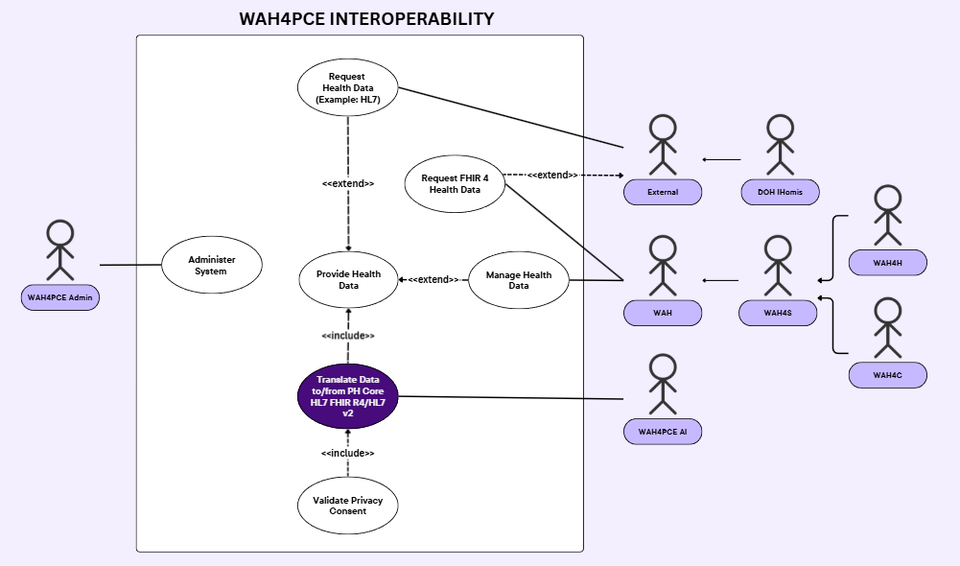

Use Case Full Description/Fully Dressed Use Case
Use Case Name: | Administer System
Scenario: | The system administrator accesses the interoperability platform to configure endpoints, manage user credentials, and monitor system health.
Triggering Event: | The WAH4PCE Admin navigates to the administrative portal and logs in.
Brief Description: | This use case governs the administrative oversight of the platform, allowing the admin to ensure network uptime, manage security, and configure system parameters.
Actors: | Primary: WAH4PCE Admin
Related Use Cases: | None
Stakeholders: | WAH4PCE Admin: Needs secure, comprehensive access to system settings.  All Users: Rely on the admin to keep the system operational and secure.
Preconditions: | The WAH4PCE Admin must be authenticated with valid administrative privileges.
Postconditions: | System configurations are successfully updated, applied, and logged in the immutable audit trail.
Flow of Activities: | Actor: WAH4PCE Admin logs into the system dashboard and selects a configuration module.  System: Authenticates the Admin and presents the requested administrative interface.  Actor: Admin inputs changes or acknowledges system alerts.  System: Commits the changes, updates the system state, and logs the activity.
Exception Conditions: | E1: Invalid Credentials. If the Admin provides incorrect login details, the System denies access and logs a failed attempt.

Use Case Name: | Provide Health Data
Scenario: | A core data ingestion or routing event occurs on the platform, acting as the base transaction engine that can optionally be extended by requests, management, or translation processes.
Triggering Event: | Triggered implicitly when an actor initiates a data transaction (either via the Request or Manage extension points).
Brief Description: | This is the foundational data handling use case. It represents the core pipeline for routing health data within the system, automatically including translation protocols when necessary, and serving as the base that other use cases extend.
Actors: | Primary: System (External, WAH)
Related Use Cases: | Request Health Data (Example: HL7) (<<extend>>) Manage Health Data (<<extend>>)  Translate Data to/from PH Core HL7 FHIR R4/HL7 v2 (<<include>>)
Stakeholders: | External / WAH Actors: Depend on this core pipeline to route data securely.  Patients: Depend on this pipeline to handle their data safely.
Preconditions: | A data transaction must be initiated by an authorized external or WAH actor.
Postconditions: | The data payload is successfully processed, translated (if necessary), and routed to its appropriate destination.
Flow of Activities: | Actor: (Triggered by extending use cases).  System: Initializes the core data pipeline and evaluates the incoming payload.  System: Hits the <<include>> point to trigger the "Translate Data..." use case to ensure standard formatting.  System: Concludes the transaction and finalizes the routing of the health data.

Exception Conditions: | E1: Pipeline Failure: If the core system experiences a critical error, the transaction is halted, and an alert is sent to the WAH4PCE Admin.

Use Case Name: | Request Health Data (Example: HL7)
Scenario: | An external organization searches the interoperable repository to retrieve specific patient records in legacy or standard HL7 format.
Triggering Event: | An External actor (e.g., DOH iHomis) submits a data query or retrieval request to the platform.
Brief Description: | This use case extends the core data pipeline to allow authorized external entities to pull interoperable health data from the repository in HL7 formats.
Actors: | Primary: External (Generalized actor including DOH iHomis)
Related Use Cases: | Provide Health Data (<<extend>>)
Stakeholders: | External Actors: Need accurate and timely access to patient records.
Preconditions: | The External actor must be authenticated and authorized to access the requested data scope.
Postconditions: | The requested HL7 data is securely delivered to the actor, and the access event is logged.
Flow of Activities: | Actor: External actor submits a data request query via the integration endpoint.  System: Verifies identity and authorization scope.  System: Executes the core "Provide Health Data" pipeline to retrieve and route the data.  System: Transmits the requested data back to the Actor.
Exception Conditions: | E1: Data Not Found: If no records match, the System returns a '404 Not Found' status.

Use Case Name: | Request FHIR 4 Health Data
Scenario: | A WAH-affiliated entity requests modern, highly structured FHIR R4 clinical data from the interoperability platform.
Triggering Event: | A WAH actor (e.g., WAH4S, WAH4H, WAH4C) submits an API request specifically for FHIR R4 formatted data.
Brief Description: | This use case governs the secure querying and extraction of modern FHIR R4 health data tailored for actors within the WAH ecosystem, with potential extended access to External actors.
Actors: | Primary: WAH (Generalized actor including WAH4H, WAH4S, WAH4C), External
Related Use Cases: | None directly shown as valid UML extensions to other use cases in this iteration.
Stakeholders: | WAH Actors: Need structured, modern data schemas for their specific clinical applications.
Preconditions: | The actor must be authenticated and the requested data must exist in or be translatable to FHIR 4.
Postconditions: | The requested FHIR 4 data is securely delivered to the actor.
Flow of Activities: | Actor: WAH actor submits a query for FHIR R4 resources.  System: Authenticates the actor and verifies access permissions.  System: Queries the repository for the FHIR resources.  System: Encrypts the payload and transmits it back to the Actor.
Exception Conditions: | E1: Unauthorized Access. If the actor requests resources outside their scope, the system denies the request and logs a security exception.

Use Case Name: | Manage Health Data
Scenario: | An authorized data owner updates, archives, or amends existing health records they previously submitted to the platform.
Triggering Event: | A WAH actor sends an update or modification payload for a specific existing record.
Brief Description: | This use case extends the core data pipeline to allow primary WAH actors to maintain the accuracy and lifecycle of their submitted data, ensuring the ecosystem contains the most current clinical information.
Actors: | Primary: WAH (Generalized actor including WAH4H, WAH4S, WAH4C)
Related Use Cases: | Provide Health Data(<<extend>>)
Stakeholders: | WAH Actors: Require the ability to amend patient information as clinical situations evolve.
Preconditions: | The target record must exist, and the WAH actor must be the authoritative owner of that record.
Postconditions: | The record is successfully updated (with version history maintained), and an audit trail is logged.
Flow of Activities: | Actor: WAH actor submits an update payload for an existing health record.  System: Validates the Actor's authority to modify this specific data asset.  System: Triggers the core "Provide Health Data" pipeline to process the payload.  System: Applies the updates, versions the record, and sends a success confirmation.
Exception Conditions: | E1: Record Locked: If the record is currently in use or locked by another process, the system rejects the update and prompts a retry.

Use Case Name: | Translate Data to/from PH Core HL7 FHIR R4/HL7 v2
Scenario: | Data flowing through the core pipeline requires structural normalization to ensure it matches the PH Core HL7 FHIR R4 or HL7 v2 standards.
Triggering Event: | Mandatorily triggered by the "Provide Health Data" use case when data ingestion or extraction occurs.
Brief Description: | This included use case utilizes an AI agent to perform complex semantic mapping and translation of health data schemas, ensuring true interoperability across the platform while enforcing a mandatory privacy check.
Actors: | Primary: WAH4PCE AI
Related Use Cases: | Provide Health Data(<<include>>) Validate Privacy Consent(<<include>>)
Stakeholders: | WAH4PCE AI: Requires parameters to map data schemas accurately.  All System Users: Depend on this process for standardized data.
Preconditions: | A data payload must be staged in memory, and the AI translation service must be operational.
Postconditions: | The data payload is successfully mapped to standard formats without losing clinical meaning.
Flow of Activities: | System: Routes the data payload to the AI agent during the core transaction.  Actor: WAH4PCE AI analyzes the schema and performs semantic mapping.  System: Pauses translation to trigger the mandatory "Validate Privacy Consent" use case.  Actor: WAH4PCE AI finalizes the standardized output and returns it to the pipeline.
Exception Conditions: | E1: Translation Failure: If the AI cannot safely map the data without altering clinical meaning, it halts, quarantines the payload, and alerts the admin.

Use Case Name: | Validate Privacy Consent
Scenario: | Before translation and processing can finalize, the system checks the patient's active consent directives to ensure data sharing is legally permitted.
Triggering Event: | Automatically and mandatorily triggered by the "Translate Data..." use case.
Brief Description: | A strict, internal compliance check that cross-references patient identifiers against consent registries to approve or block the processing of health information.
Actors: | Primary: System
Related Use Cases: | Translate Data to/from PH Core HL7 FHIR R4/HL7 v2 (<<include>>)
Stakeholders: | Patients: Require strict adherence to their privacy choices.  WAH4PCE Admin: Needs a reliable audit trail of compliance checks.
Preconditions: | Patient identifiers must be parsable from the payload, and the consent registry must be online.
Postconditions: | A consent status is appended to the transaction, and the verification event is logged.
Flow of Activities: | System: Extracts patient identifiers from the active payload.  System: Queries the consent registry for the patient's sharing permissions.  System: Evaluates permissions against the current transaction.  System: Returns an authorization approval back to the translation process.
Exception Conditions: | E1: Consent Revoked: If the registry indicates an opt-out, the System immediately purges the payload, aborts processing, and logs a compliance rejection.

Gap Analysis

Product Backlog ID | Current System | Proposed Changes | Impact

System Analysis and Design

System Context Diagram
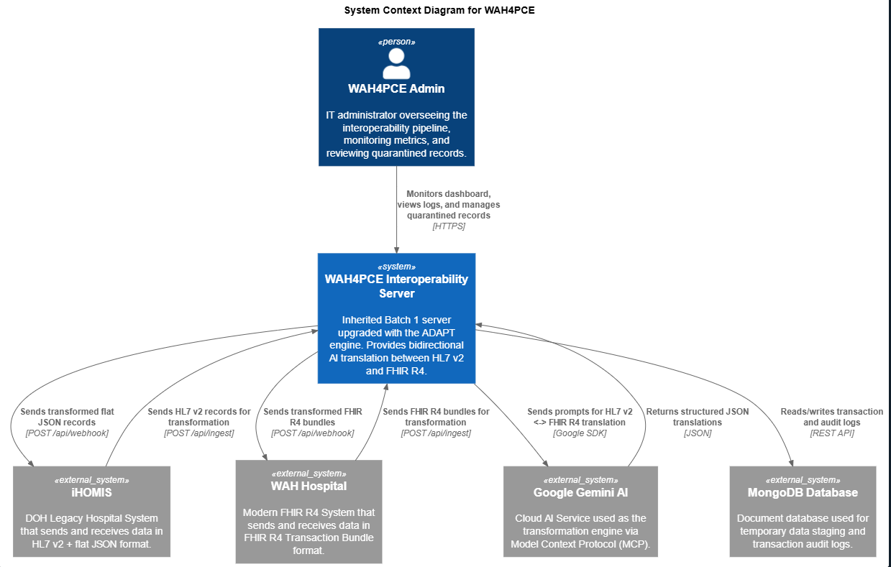

Container Diagram
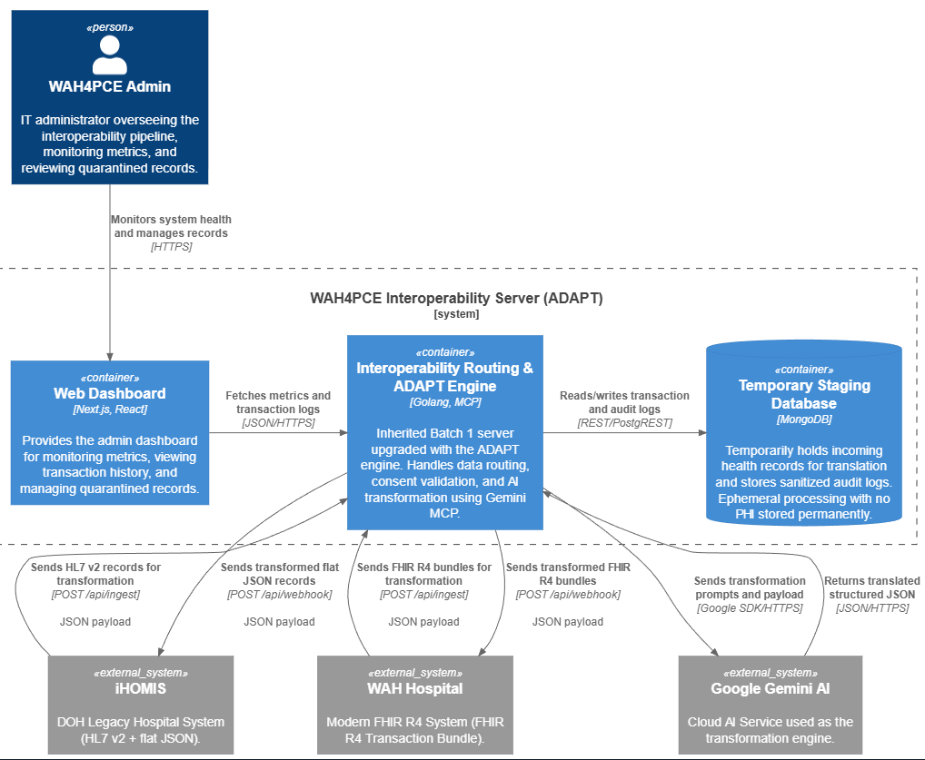

Component Diagram
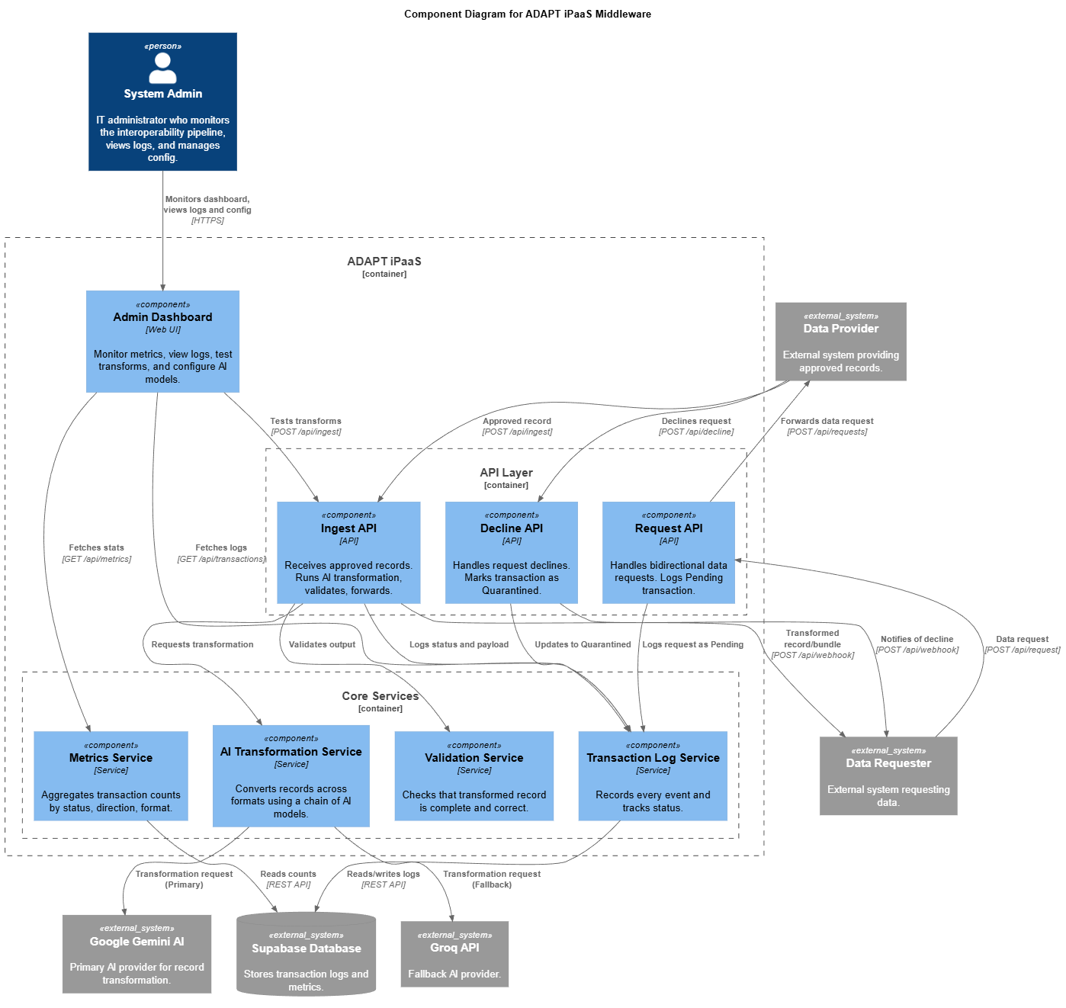

Entity Relationship Diagram
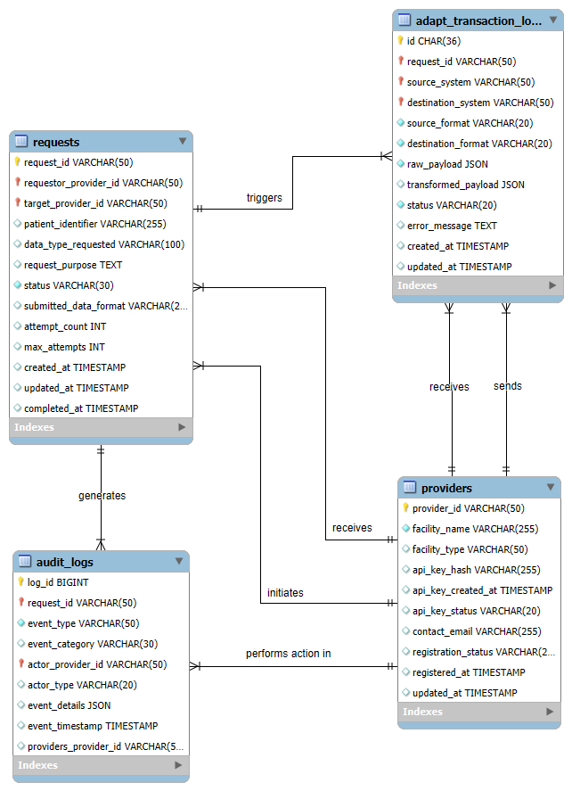

Results and Discussion
(
Write a short introduction that describes what this section will discuss.
)

5.1 Release Plan
(
Include here your updated release plan and discuss whether you are on/ahead/behind schedule. Explain also how much of the product backlog has been finished (it is up to you how you will present it, without being repetitive. You can say something like, “The complete product backlog is in Table ___”.
)

5.2 Prototype
(
Include here diagrams/illustrations of your proposed solution. Include the latest screenshots. Note that each figure must be properly captioned and discussed in at least one paragraph.
)

5.3 Use Classes and Characteristics

(
Insert a table here with two columns: Roles and Description
Roles | Description
Student Org Representative | A student organization representative is a type of user. When this user makes a request, the request must be approved by the org adviser, etc..
Org adviser | This user approves or disapproves the request made by the representatives of the org he/she handles.

)

Conclusion
(
Write what you have accomplished so far (which of your objectives have been achieved and what needs to be done to achieve the others, if there are still any left). Summarize what you have done: specify the objectives and briefly describe how it was achieved. At the end of this chapter, write what will be done for the next iteration (for the next course in the PBL flow of subjects—MCSPROJ)
)

References
[1] K. Adegoke et al., "Interoperability as a Catalyst for Digital Health and Therapeutics: A
Scoping Review of Emerging Technologies and Standards (2015–2025)," International Journal
of Environmental Research and Public Health, vol. 22, no. 10, p. 1535, 2025, doi:
10.3390/ijerph22101535.
[2] M. Alshurideh et al., "Assessing the impact of digital transformation on healthcare services: A
focus on quality and safety," BMJ Open Quality, vol. 13, no. 2, p. e002621, 2024, doi:
10.1136/bmjoq-2023-002621.
[3] F. Amar, A. April, and A. Abran, "Electronic health record and semantic issues using Fast
Healthcare Interoperability Resources: Systematic mapping review," Journal of Medical Internet
Research, vol. 26, p. e45209, 2024, doi: 10.2196/45209.
[4] S. Arnaout, N. Jeanty, H. Keane, and G. Mkemwa, "The Effect of the Wireless Access for
Health Electronic Health Record System on Rural Health Units in the Philippines," Wireless
Access for Health, 2014. [Online]. Available: https://wah.ph/wp-content/uploads/2023/07/TheEffect-of-the-Wireless-Access-for-Health-Electronic-Health-Record-System-on-Rural-HealthUnits-in-the-Philippines.pdf
[5] J. A. Balch et al., "Machine Learning–Enabled Clinical Information systems using fast
healthcare interoperability Resources Data Standards: Scoping review," JMIR Medical
Informatics, vol. 11, p. e48297, 2023, doi: 10.2196/48297.
[6] I. Bossenko, R. Randmaa, G. Piho, and P. Ross, "Interoperability of health data using FHIR
Mapping Language: transforming HL7 CDA to FHIR with reusable visual components," Frontiers
in Digital Health, vol. 6, p. 1480600, 2024, doi: 10.3389/fdgth.2024.1480600.
[7] M. C. T. Cecilio, C. A. Garcia, and J. R. B. Tengco, "Wireless access for health for
interoperability," School of Computing and Information Technologies, Asia Pacific College, n.d.
[Unpublished project documentation].
[8] A. Charalambous, "Digital transformation in healthcare: Have we gone off the rails?" AsiaPacific Journal of Oncology Nursing, vol. 11, no. 5, p. 100481, 2024, doi:
10.1016/j.apjon.2024.100481.
[9] Department of Health & Philippine Health Insurance Corporation, "Mandatory adoption and
use of national health data standards for interoperability (Joint Administrative Order No. 2021-
0002)," Apr. 21, 2021. [Online]. Available: https://law.upd.edu.ph/wpcontent/uploads/2021/06/DOH-PHIC-JAO-No-2021-002.pdf
[10] Inquirer Business, "Enabling universal health care in the Philippines," Jun. 9, 2025. [Online].
Available: https://business.inquirer.net/529621/enabling-universal-health-care-in-the-philippines
[11] J. Nan and X. Xu, "Designing Interoperable health care services based on Fast healthcare
Interoperability Resources: Literature review," JMIR Medical Informatics, vol. 11, p. e44842,
2023, doi: 10.2196/44842.
46
[12] A. A. Nassr, H. R. Al-Shamayleh, and M. F. Al-Shboul, "Digital transformation in healthcare:
Technology acceptance and its applications," WSEAS Transactions on Systems and Control,
vol. 18, pp. 86–95, 2023, doi: 10.37394/23203.2023.18.10.
[13] A. M. Ongkeko, Jr. et al., "Community health information and tracking system (CHITS):
Lessons from eight years implementation of a pioneer electronic medical record system in the
Philippines," Acta Medica Philippina, vol. 50, no. 4, pp. 265–273, 2016.
[14] Philippine Council for Health Research and Development, "Community health information
tracking system (CHITS)," n.d. [Online]. Available:
https://www.pchrd.dost.gov.ph/heartnovation/community-health-information-tracking-systemchits/
[15] Philippine Information Agency, "DOH launches integrated info system for healthcare
improvement," Feb. 28, 2024. [Online]. Available: https://pia.gov.ph/doh-launches-integratedinfo-system-for-healthcare-improvement/
[16] Philippine Statistics Authority, "PSA clears the “Evaluation of the Universal Health Care
(UHC) health information systems (HIS)” survey, encourages participation for data-driven
evaluation by HIS interoperability, functionality, and impact on UHC implementation," Apr. 30,
2025. [Online]. Available: https://psa.gov.ph/content/psa-clears-evaluation-universal-healthcare-uhc-health-information-systems-his-survey
[17] Republic Act no. 11223, Official Gazette of the Republic of the Philippines, 2019. [Online].
Available: https://www.officialgazette.gov.ph/2019/02/20/republic-act-no-11223/
[18] Scribd, "Integrated hospital operations and management information system (iHOMIS),"
Nov. 9, 2021. [Online]. Available: https://www.scribd.com/presentation/543228631/IHOMISPresentation
[19] Simbo.ai, "Understanding electronic health records: Benefits and implementation
challenges in modern healthcare delivery systems," Nov. 17, 2023. [Online]. Available:
https://www.simbo.ai/blog/understanding-electronic-health-records-benefits-andimplementation-challenges-in-modern-healthcare-delivery-systems-1611764/
[20] A. A. Sinaci et al., "A data transformation methodology to create findable, accessible,
interoperable, and reusable health data: Software design, development, and evaluation study,"
Journal of Medical Internet Research, vol. 25, p. e42822, 2023, doi: 10.2196/42822.
[21] R. Singh, N. Mathur, A. Singh, S. Sangwan, and A. Pitalia, "Artificial intelligence-guided
clinical decision support system for early prediction of neonatal sepsis: A prospective diagnostic
validation study," Asia Pacific Journal of Oncology Nursing, vol. 11, no. 4, p. 100401, 2024, doi:
10.1016/j.apjon.2024.100401.
[22] ThinkWell Global, "The Philippine UHC law series: Brief 1," n.d. [Online]. Available:
https://thinkwell.global/wp-content/uploads/2020/05/PH-UHC-Law-Series_Brief-1.pdf
[23] University of the Philippines Manila Standards and Interoperability Lab, "PH Core
implementation guide," n.d. [Online]. Available: https://build.fhir.org/ig/UP-Manila-SILab/ph-core/
47
[24] C. N. Vorisek et al., "FaST Healthcare Interoperability Resources (FHIR) for Interoperability
in Health Research: Systematic review," JMIR Medical Informatics, vol. 10, no. 7, p. e35724,
2022, doi: 10.2196/35724.
[25] S. Jayaraman and A. Singh, "Best Practices in Microservices Architecture for CrossIndustry Interoperability," International Journal of Computer Science and Engineering, vol. 13,
no. 2, pp. 353-398, Nov. 2024.
[26] J. Abraham, A. Meng, K. J. Holzer, L. Brawer, A. Casarella, M. Avidan, and M. C. Politi,
"Exploring patient perspectives on telemedicine monitoring within the operating room,"
International Journal of Medical Informatics, vol. 156, p. 104595, Dec. 2021, doi:
10.1016/j.ijmedinf.2021.104595.

[27] N. Yadav, S. Pandey, A. Gupta, P. Dudani, S. Gupta, and K. Rangarajan, "Data privacy in
healthcare: In the era of artificial intelligence," Indian Dermatology Online Journal, vol. 14, no. 6,
pp. 788–792, Oct. 2023, doi: 10.4103/idoj.idoj_543_23.
[28] S. Pasupuleti, "The Medallion Architecture in Data Engineering: A Layered Approach to Data Quality and Governance," ResearchGate, Nov. 2025. [Online]. Available: https://www.researchgate.net/publication/397789156_The_Medallion_Architecture_in_Data_Engineering_A_Layered_Approach_to_Data_Quality_and_Governance
[29] R. Bodle, "Regimes of Sharing: Open APIs, Interoperability, and Facebook," Information, Communication & Society, vol. 14, no. 3, pp. 320-337, Apr. 2011, doi: 10.1080/1369118X.2010.542825.
[30] T. Pardi, "LLM-Augmented Algorithmic Management: A Governance-Oriented Architecture for Explainable Organizational Decision Systems," AI, vol. 7, no. 3, p. 102, 2026. Available: https://www.mdpi.com/2673-2688/7/3/102

Appendices

Appendix A: Project Vision
(
Write your updated project vision, please refer to the reference uploaded in MS Teams
)

Appendix B: Schedule
(
Gantt chart or table containing your project schedule.
)

Appendix C: Product Roadmap
(
Updated product roadmap file here. Make sure that content is readable
)

Appendix D: Users’ Manual
(
Add this section only if you think Section 5.2 is not sufficient for users to grasp how your system works.
)

Appendix E: Team Meetings

Meetings with Project Adviser

With Project Adviser - Minutes of the Meeting 1
1. Meeting Details
- Project / Topic: Group Merge Conflict Project Advisory Consultation
- Date: August 4, 2026
- Time: 03:36
- Platform: Microsoft Teams
- Recorded By: Marwin John Gonzales
- Attendees Present:
  - Gil Ballesca (Project Adviser)
  - Rick Francis Cruz (Backend Developer)
  - Qelvin Joszeler Nagales (Project Manager / Lead)
  - Vince Nelmar Alobin (Full-Stack Developer)
2. Key Agenda & Discussions
A. Adviser Introduction & Role Alignment
- Advisor Experience & Background: Adviser Gil Ballesca shared his background, including working remotely for an AI company established with partners in Australia. He expressed appreciation for being selected as the team's project adviser.
- Consultation Expectations: Mr. Ballesca clarified that while he will be advising the team collectively, he will also hold individual consultations with team members based on their specific roles (e.g., backend, full-stack, frontend) to review responsibilities and progress.

B. Technical Stack & Development Status
- Roles & Responsibilities:
  - Rick Francis Cruz: Serves primarily as the Backend Developer.
  - Vince Nelmar Alobin: Serves as the Full-Stack Developer, collaborating with Qelvin on client-side requirements and working closely on the backend and database architecture.
- Technology Stack:
  - Frontend & Framework: Next.js (built on React), following the tech stack established by previous student batches (e.g., iBugs, TCG Trio).
  - Database & Staging: Currently using dummy data / Convex for prototyping and demonstration purposes to transfer data across systems.
- Current Progress:
  - Prototyping: Although formal code development isn't required yet at this stage, the team has already created a working prototype to help the thesis panel visualize system workflows.
  - Database Schema: The team is currently in the diagramming phase (mapping schema, relationships, and metadata) and will establish the final database schema ahead of the final defense.
C. Scope Management & Advisory Guidance
- Addressing Panel Feedback:
  - Rick noted that while the client (WAH) approved their working prototype, the main challenge during midterms/defense was panel feedback regarding paper wording and scope.
  - Panel members for the project were identified as Ms. Roselle, Sir Gonz, and Sir June, alongside client representatives from WAH.
- Scope Realism & "Over-scoping":
  - Adviser Gil Ballesca warned against over-scoping the project. He noted that academic panels sometimes request overly complex features (e.g., full hospital management systems or complex agentic AI) that exceed realistic student timeframes.
  - He emphasized that the goal of the thesis is to prove a specific working theory/solution to a defined problem within a 1-to-2-hour defense, rather than trying to build a multi-billion dollar enterprise application.
- Strategic Alignment:
  - The adviser committed to helping the team structure, negotiate, and defend a balanced, proper scope in their documentation and presentation so panel requirements remain fair, realistic, and achievable.

3. Action Items
# | Action Item | Assigned To | Target Timeline
1 | Share the compiled panel recommendations and paper draft in the team group chat for adviser review. | Qelvin Nagales & Rick Cruz | Immediate / Within the week
2 | Finalize database schema diagrams, entity relationships, and metadata definitions. | Rick Cruz & Vince Alobin | Next Advisory Check
3 | Review paper wording and trim down over-scoped objectives to focus strictly on the core problem statement. | Whole Team & Gil Ballesca | Ongoing / Prior to Defense

4. Meeting Adjournment
The meeting concluded with closing remarks and words of encouragement from Adviser Gil Ballesca as the team prepares for their upcoming documentation reviews and in-person alignment.

5. Meeting Documentation


With Project Adviser - Minutes of the Meeting 2
1. Meeting Details
- Project / Topic: WAH4PCE Architecture Review & Advisory Consultation (Merge Conflict Team)
- Date: August 7, 2026
- Time: 3:30 PM – 4:30 PM (PST)
- Venue: Asia Pacific College Consultation Room - B 403D
- Attendees Present:
  - Gil Ballesca (Project Adviser)
  - Marwin John Gonzales (Project Manager / Developer)
  - Qelvin Joszeler Nagales (Team Lead / Project Manager)
  - Vince Nelmar P. Alobin (Co-Lead / Developer)
  - Rick Francis T. Cruz (Backend Developer / QA)

2. Key Agenda & Discussions
A. Paper Review & Structure Alignment
- Introduction & Problem Statement: Reviewed the core background of bridging Wireless Access for Health (WAH) facilities with external iHOMIS systems to overcome disconnected "data islands."
- Objectives & Scope: Evaluated the overall scope of the project to ensure the team's goals remain achievable within the academic and development timeline without being overly ambitious or under-scoped.
- Significance of the Study: Discussed how the project benefits WAH, DOH, healthcare workers, and patients by reducing double data entry and facilitating smooth record transfers.
B. Specific Adviser Feedback & Technical Direction
- Data Privacy Requirements (Client - WAH):
  - Guidance: Adviser Gil Ballesca emphasized that the team must conduct deeper research into the client's (WAH) data privacy requirements and legal constraints under the Data Privacy Act (RA 10173).
  - Action: Further investigate automated consent flags and waiver handling to ensure compliance before any cross-facility data exchange occurs.
- Architecture Scope (Direct Hospital-to-Hospital vs. Centralized Database):
  - Guidance: The adviser noted that establishing a full direct hospital-to-hospital (p2p/federated) routing network in one of the current objectives is too large and overly ambitious for the current project scope.
  - Direction: The team was advised to maintain/keep a centralized database approach to ensure the system architecture remains manageable, stable, and deliverable.
- API Key Security & Storage:
  - Guidance: The adviser raised concerns regarding key management and security.
  - Direction: The team needs to put more thought into safe storage strategies for API keys (e.g., environment variables, secure key vaults, or encrypted server storage) to prevent unauthorized access.
- Use Case Diagram (UCD) Revision:
  - Guidance: The adviser reviewed the Use Case Diagram in the paper and noted that the current version is too simple and lacks the necessary depth to reflect the actual system capabilities.
  - Direction: The UCD needs to be expanded and updated to clearly define actors, system boundaries, and sub-processes (such as validation, consent checking, and quarantine queues).

3. Action Items
# | Action Item | Assigned To | Target Timeline
1 | Research client-specific (WAH) data privacy protocols and update the consent validation workflow in the documentation. | Vince Alobin & Rick Cruz | Next Advisory Check
2 | Revise the project objectives and architecture diagrams to align with a centralized database structure instead of direct hospital-to-hospital routing. | Marwin Gonzales & Vince Alobin | Next Advisory Check
3 | Formulate a secure API key storage strategy and document it in the Technical Background section. | Rick Cruz | Next Advisory Check
4 | Redraw and expand the Use Case Diagram (UCD) to add proper operational detail and complexity. | Qelvin Nagales & Vince Alobin | Next Advisory Check

4. Meeting Adjournment
The consultation ended at 4:30 PM with clear directives on refining the project paper and scaling back ambitious objectives into a solid, defensible thesis scope.
5. Meeting Documentation
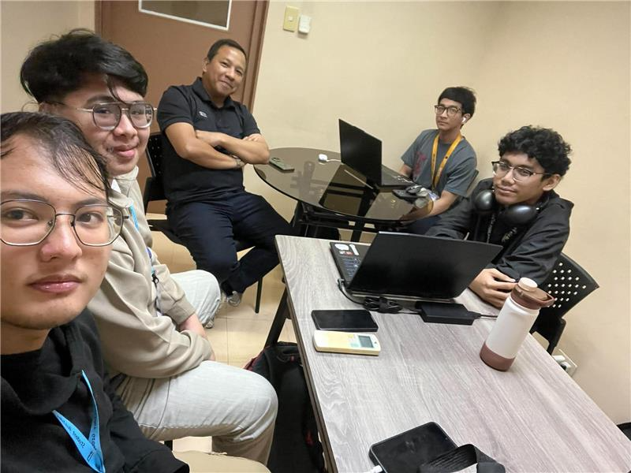

With Project Adviser - Minutes of the Meeting 3
Meeting Details
- Meeting Title: Merge Conflict – Weekly Meeting
- Date & Time: August 14, 2026 | 3:30 PM – 4:30 PM (UTC 07:30)
- Organizer / Recorder: Qelvin Joszeler Nagales
- Platform: Microsoft Teams
Attendees
- Advisor / Mentor: Gil Ballesca
- Team Members:
  - Qelvin Joszeler Nagales
  - Vince Nelmar Alobin
  - Rick Francis Cruz
  - Marwin John Gonzales
Agenda & Discussion Highlights
1. Project Updates & Previous Meeting Follow-ups
- Sync with WAH: The team reported holding a meeting with WAH the previous day. Key architectural points discussed included the Medallion architecture and Open API considerations.
- Integration Approaches: Three approaches were presented to WAH:
  - Pure Algorithm-based
  - Pure AI-based
  - Hybrid (Algorithm + AI Integration)
WAH expressed a preference for whichever approach is most accurate, precise, efficient, and fast for translating health data.
2. Standards & Architecture (HL7 vs. FHIR / PH Core IG)
- Standard Compatibility:
  - The team presented the WAH4PCE Interoperability Use Case Diagram (UCD), which was previously checked and approved by their professor (Sir Shan).
  - The discussion covered how external systems (e.g., DOH iHOMIS) use HL7 v2 while modern frameworks utilize HL7 FHIR (PH Core IG).
  - Sir Gil noted that since the Philippine FHIR standard (Draft PH Core IG) is still under active development and not final, relying too heavily on an unstable specification poses a risk of rework.
  - Advice on Standards: The team was advised to anchor core transformation reliability on stable standards (like HL7) and implement proper mapping/adapter design patterns to manage data variations.
3. Demo & Technical Prototype (ADAPT iPaaS)
- Vince presented the live prototype demonstrating data mapping and transformation between WAH (FHIR R4) and DOH iHOMIS (HL7 v2):
  - Data Privacy Validation: Showcased automatic validation where records missing patient privacy consent under Republic Act 10173 are quarantined and rejected from being pushed to destination endpoints.
  - Field Discrepancies & Unmapped Data: Discussed how iHOMIS contains specific fields (e.g., separate chief complaints, diagnosis descriptions) that may not map 1:1 with standard FHIR conditions.
  - Recommendation on Custom Fields: Sir Gil suggested implementing custom fields/metadata handling for unmapped attributes to prevent loss of critical clinical context.
4. AI vs. Algorithm Implementation Strategy
- Token Costs & Sustainability: Sir Gil emphasized the high recurring costs, token limitations, latency, and potential downtimes associated with relying purely on external LLMs/AI APIs for high-volume enterprise health data.
- Recommended Strategy:
  - Prioritize a deterministic, precise algorithm as the primary engine for schema transformations and data mapping.
  - Use AI as an auxiliary feature or fallback, or apply AI to higher-level clinical decision support/triage (e.g., analyzing vital signs anomalies and alerting emergency cases) rather than basic structural field mapping.
Action Items
Task / Deliverable | Assignee(s) | Target Date
Update and refine the Use Case Diagram (UCD) to align with the dual Algorithm + AI fallback architecture | Merge Conflict Team | Prior to Project Defense
Formulate algorithm-based mapping logic as the primary pipeline and prepare AI fallback error handling | Vince Nelmar Alobin / Dev Team | Ongoing
Prepare a business proposal/comparison analyzing model costs (Claude, Gemini, GPT) vs. algorithmic processing for WAH | Merge Conflict Team | Next Sync
Update WAH regarding project progress, architecture decisions, and scope boundaries | Merge Conflict Team | Immediate
Add Sir Gil Ballesca to the official communication group (Messenger/Email) to ensure he stays in the loop | Qelvin Joszeler Nagales | Immediate

Next Meeting Schedule
- Date: Monday, August 17, 2026
- Time: 11:30 AM – 12:30 PM
- Cadence: Twice weekly (Mondays and Fridays) leading up to project defense

5. Meeting Documentation
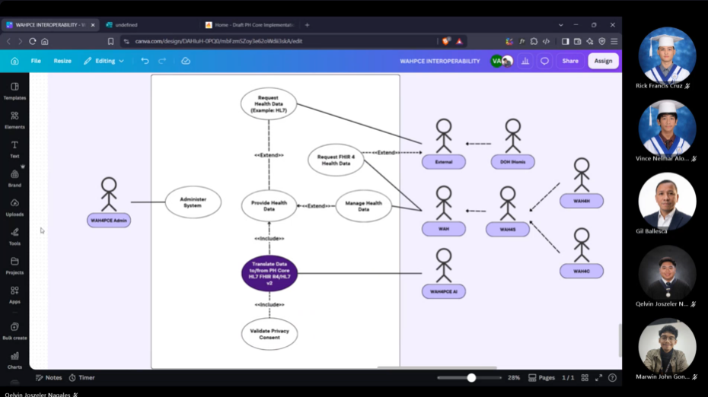

Meetings with Client

With Client - Minutes of the Meeting 1
1. Meeting Details
- Project / Topic: Interoperability Architecture & Data Translation (WAH, iHOMIS, DOH)
- Date: August 13, 2026
- Time: 11:05 AM – 11:46 AM (PST)
- Platform: Google Meet (hiw-rclk-mwr)
- Attendees Present:
  - Nicky Balderosa
  - Qelvin Nagales
  - Vince Nelmar Alobin
  - Rick Cruz
  - Robert Michael Martinez
  - Marwin John Gonzales
2. Key Agenda & Discussions
A. System Scope & Deliverables
- External Connections & APIs: The team clarified that their scope is to build the intermediary interoperability layer (API endpoints and documentation) so external systems (such as WAH and iHOMIS) can communicate.
- DOH Reports: DOH health reports (e.g., PDFs generated via EMR/iHOMIS) are currently extracted/printed and submitted manually. Automating direct report sync from the interoperability layer to DOH is out of scope.
- Midterm Defense Requirement: For the upcoming midterm defense, the team only needs to present system architecture/diagrams (working code is not required yet).
B. Translation Approach: Algorithm vs. AI
The team discussed the translation of incoming health data into standard JSON formats:
- Algorithm-Based Translation: Faster, highly efficient, precise, and cost-effective (no token costs).
- AI-Based Translation: Flexible, requires less initial development logic, but incurs API token costs and potential latency.
- Hybrid / Backup Approach: Suggestion to primary use algorithm-based translation, with AI serving as a fallback/safety net for edge cases.
- Evaluation Criteria: Nicky emphasized that accuracy and precision are priority #1. Priority #2 is maintainability—the chosen approach must be easy for the core team to maintain long-term.

C. Data Flow & Integration Alignments
- Data Format Handling: Vince raised a question regarding JSON conversions for data originating from WAH-Hospital and WAH-Clinic sent to iHOMIS or central storage.
- Platform Alignment (OpenHIM): It was noted that other groups (e.g., Fam's team) are looking into OpenHIM. Nicky advised coordinating with team leads (Jello & Sophia) to prevent redundant work and ensure alignment across all 4 sub-teams.
D. Security & Testing
- System security testing and vulnerability enhancements will be handled by the dedicated security sub-team.

3. Action Items
# | Action Item | Assigned To | Target Timeline
1 | Meet with sub-team leads (Jello & Sophia) to align on OpenHIM and avoid redundant effort. | Core Interop Team | Prior to Midterm Defense
2 | Finalize architecture diagrams and data flow documentation for the midterm defense. | Core Interop Team | Next Week
3 | Evaluate algorithm vs. AI translation trade-offs and select the official primary pipeline. | Core Interop Team | Post-Midterms

4. Meeting Adjournment
The meeting was formally adjourned after addressing all open questions from the participants.

5. Meeting Documentation
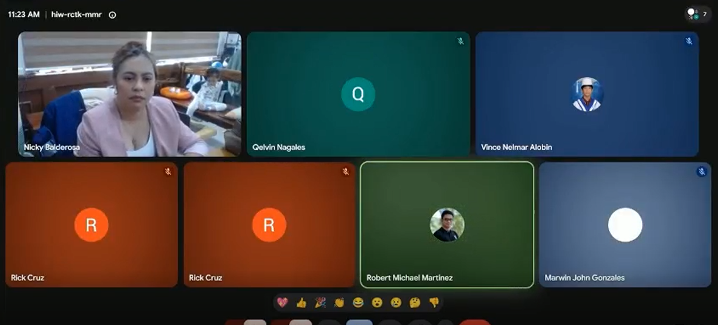

Appendix F: Source Code

https://github.com/APC-SoCIT/APC-2026-2027-T1-IT241-Grp3-WAH4PCE-An-AI-Driven-Interoperability-Bridge-for-iHOMIS
